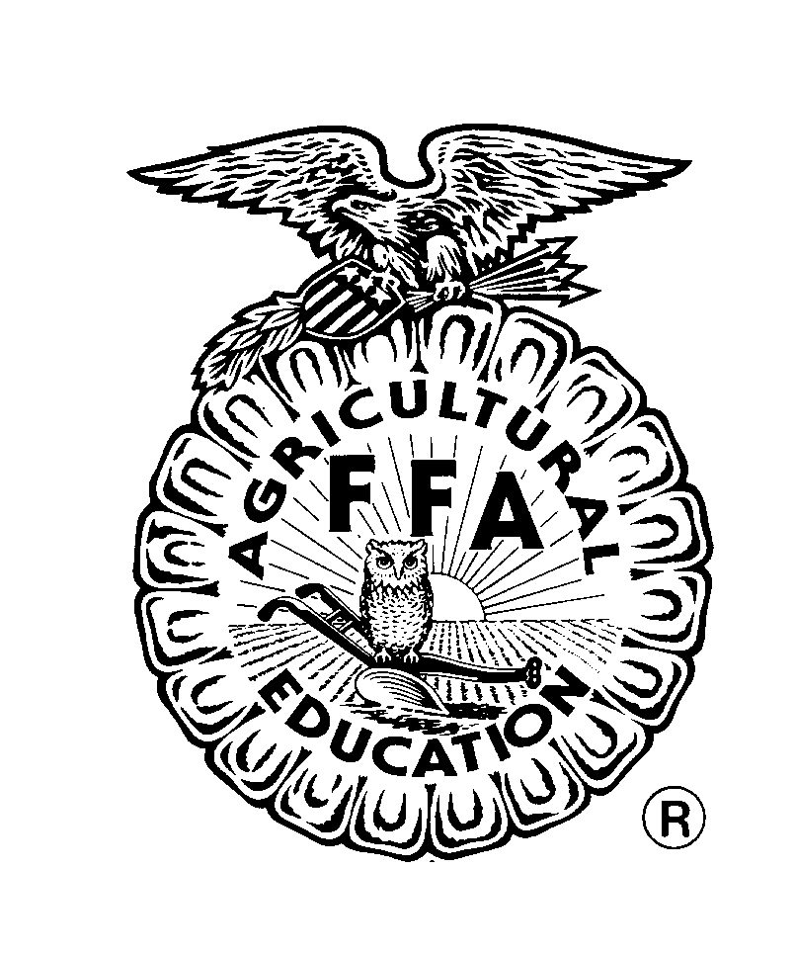Small Power Equipment
Spring 2011 Course Syllabus
Credit: ½

Instructor: | Cameron White
Room Number: | 504
Planning: | 2nd Period
Phone: | (859) 384-5040 ext. 2504
E-mail: | cameron.white@boone.kyschools.us
Website: | http://sites.google.com/site/cooperaged/

I. COURSE DESCRIPTION
This course is designed to develop skills in maintenance, repair, and operation of equipment, small internal combustion-type engines and electric motors. Content may be enhanced with appropriate computer applications. Leadership development will be provided through FFA. Each student will be encouraged to have a supervised agricultural experience program.

II. COURSE CONTENT
Course units will include the following as time allows:
- Engine Development History
- Safety
- Engine Operation Basics
- Engine Teardown
- Engine Maintenance

III. COURSE EXPECTATIONS
School wide expectations and procedures will apply for this course; however, the following are my own expectations for you as students in this course.
1. Be responsible.
2. Be respectful.
3. Be safe.
4. Be prepared.

IV. FFA AND SAE
The FFA is the official organization of agricultural education. FFA is an integral part of course curriculum and appropriate aspects of the FFA will be discussed in class. Students are highly encouraged to be involved in FFA to complement their experiences in the classroom and further develop their interpersonal and leadership skills. Students are also encouraged to participate in a supervised agricultural experience program (SAE). SAE is the experiential learning component of agricultural education. Opportunities to be involved in SAE will be discussed further throughout the year.

V. OTHER PROCEDURES
- Enter this classroom in a respectful manner. Allow students in the class before you to leave before you enter. You should be ready to work when the bell rings.
- If you miss one or more class periods, pick up information on what you missed as you enter class before the bell rings. If you fail to do this, wait until you have individual work and then get materials. Once you have retrieved your materials, if you have a question please ask me at the end of class before you leave that day. You will have 3 days to complete a make-up assignment.
- If you miss a test, you will have 1 week to make up the test. Tests must be made up after school.
- Leaving the classroom is permitted with your agenda and your specific hall pass. Ask permission to leave at appropriate times; fill out your agenda and bring it and your hall pass to me to sign before leaving. Do not interrupt a lesson; the answer will be “No” everytime. (Exception: If there is an emergency situation [i.e. you are about to vomit in the floor], go straight to the restroom. Explain when you get back. Be sure it’s an appropriate emergency.) You will not be permitted to leave the classroom the first or last 5 minutes of class.
- The FFA sells beef jerky and I do have beef jerky. Ask for jerky at appropriate times only (i.e. during individual or group work; not while I am teaching or another students is speaking). Do not interrupt a class to come get beef jerky from me. If you buy hot jerky, be prepared. Don’t eat it unless you already have something to drink with you. If you are an FFA member, don’t sell your jerky in the middle of my class (or any other class for that matter).
- If we have a visitor to the class (administrator, parent, other teacher, etc.) you should be respectful. If you are working on a project and the visitor is looking over your shoulder, please invite them to see and offer to explain the assignment. Do not yell at your favorite teacher from across the room or out in the hallway.
- If you see something that can be improved in class, please let me know after class. I can address any issues at appropriate times, but the middle of a lesson is not the time.
- If you finish an assignment early stay busy and quiet out of respect for those not finished. There are magazines or books if you would like to read, crossword puzzles and word searches, coloring pages, and a puzzle (only two people at the puzzle at a time). Please let me know (quietly) before you get any of these items.
- Groups and partners are based on those sitting closest to you. The 3 people in your general vicinity are your group members if given group work. The individual sitting directly next you is your partner for work done with partners. Groups/partners should not share responses or answers with other groups/partners unless instructed to do so.
- When the bell rings wait for me to dismiss you.
- Before leaving the classroom, clean up your area. Throw away trash and clean up any messes that you have made.
- Items on or behind my desk are for my use. If you need to borrow the stapler or tape, please ask; don’t just take.
- Late work will be accepted with appropriate grade reductions. Two days after an assignment is due, you will receive a maximum of a 70% on that assignment. Remember, a 70% is better than nothing.
- Other procedures will be discussed as they come up in class (test re-takes and corrections, etc.)
VI. ASSESSMENT AND REQUIRED MATERIALS
GRADING SCALE
This course will use the RCHS grading scale found in your student handbook/agenda.
GRADE CALCULATION
Your grade in this course will be based on the following types of grades:
Daily Assignments – 30%
Tests – 30%
Written Pieces – 30%
Notebook – 10%
DESCRIPTION OF GRADE TYPES
Daily Assignments: Daily assignments will include worksheets, activity and group participation, presentations, speeches, and weekly quiz reviews. Each Friday you will have a quiz over the previous week’s content. This “quiz” will likely be 10 questions and be worth more points than other daily work.
Tests: Each unit in this course will conclude with a test. Some tests will consist of multiple choice and open responses while others may be practical. In addition, quizzes may be given periodically to test knowledge of course content. Other assignments which test knowledge of an entire unit may be counted as a test grade.
Notebook: Every student will be required to compile a notebook in class. We will use these notebooks on a day to day basis and they will be your study guide for tests.Your notebook grade will be obtained through random checks throughout the semester worth 50 points each. The final notebook check at the end of the semester will count as a 100 point test grade. As long as your notebook is divided and you are keeping materials organized (tests are not with notes, etc.) you will get your points.
Written Pieces: Written pieces will include open response prompts, on-demand writing, written projects, speeches, and presentations. Written assignments will vary and be given periodically throughout the year.
REQUIRED MATERIALS
1” 3-ring binder - This will serve as your notebook.
Loose leaf paper – To place in your notebook.
Notebook Dividers – You will need 3 notebook dividers for organizational purposes. Your notebook should be divided into three sections: Notes, Handouts, & Tests
Calculator – Some days you will need a calculator. You will be informed the day before that class if you will need a calculator.
Paper Towels/Shop Rags – I ask that each student in the class bring in 1 roll or package of paper towels or disposable shop rags to build up our classroom supplies. We will need a substantial amount to clean up our messes.
Please detach and return this page to the instructor by January 7th.
…………………………………………………………………………………………………………………………...

VII. STUDENT & PARENT/GUARDIAN SIGNATURES

By signing, I agree that I have read and understand the contents of this syllabus. I agree to abide by the expectations outlined in this course and will complete assignments to the best of my ability.

________________________ ________________________ __________
Student Name Student Signature Date

________________________ ________________________ __________
Parent/Guardian Name Parent/Guardian Signature Date

…………………………………………………………………………………………………………………………...

VIII. COOPER FFA FACEBOOK

FFA is an integral part of agricultural education and students are strongly encouraged to join and participate in the various leadership activities. Cooper FFA has a Facebook page. If you are a current user of Facebook you can search for our page and “like” us to receive updates on upcoming events. Parents, members, and former members can like our group.

